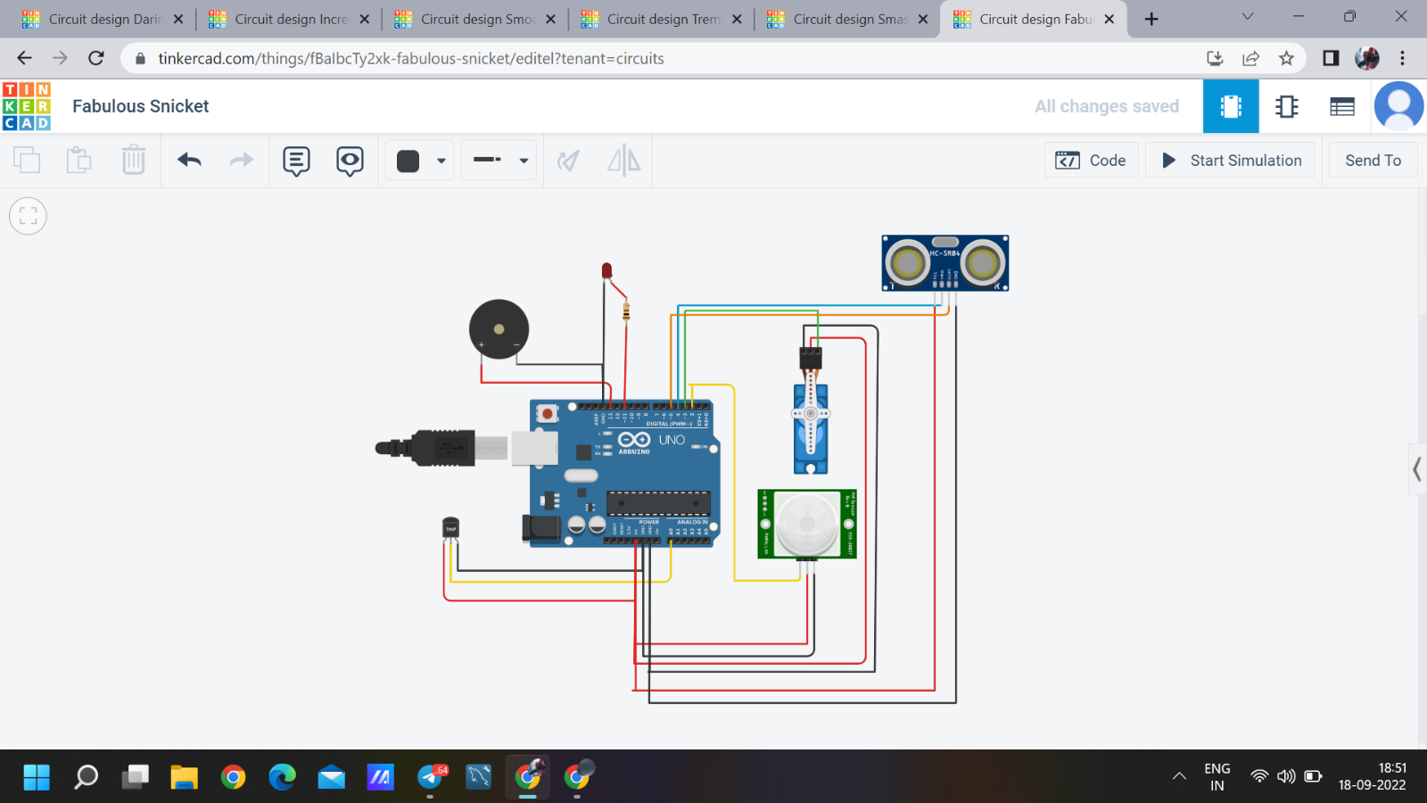

#include<Servo.h>

Servo p;

int o=4;

int e=5;

void setup()

{

pinMode(13,OUTPUT);

Serial.begin(9600);

p.attach(3);

pinMode(o,OUTPUT);

pinMode(e,INPUT);

pinMode(11,OUTPUT);

}

void loop()

{

double a=analogRead(A0);

double s=(((a/1024)\*5)-0.5)\*100;

Serial.println("Temperature value");

Serial.println(s);

if(s>40){

Serial.println("High temperature");

tone(13,500);

}

else{

noTone(13);

}

p.write(0);

int t=digitalRead(2);

if(t==1){

Serial.println("Door open");

p.write(90);

delay(1000);

}

digitalWrite(o,0);

digitalWrite(o,1);

delayMicroseconds(1000);

digitalWrite(o,0);

float dur=pulseIn(e,1);

int dis=(dur\*0.0343)/2;

int w=map(dis,2,330,100,255);

analogWrite(11,w);

}